Riphah

NAME:SALMA RANI

Sap_id:54194

lab 3

computer architecture

**Task 1**

* 1. Design and simulate a simple NAND Gate using switches instead of logic states.

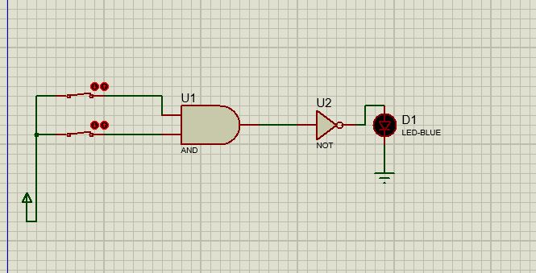

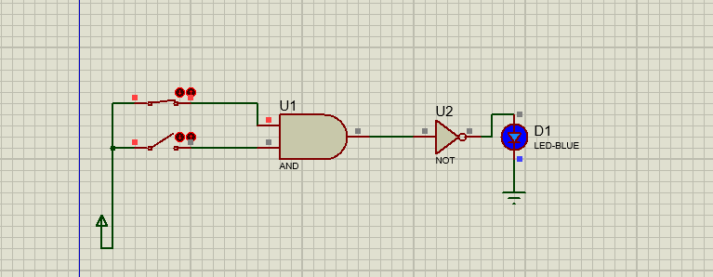

**Task 2**

Design and simulate XNOR Gate.

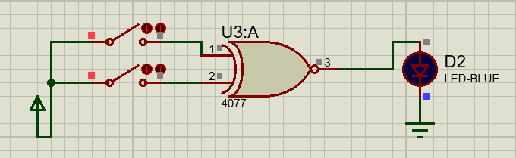

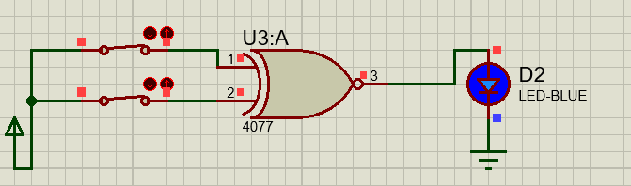

**Task 3**

Design and simulate a half Subtractor.

